Station #1: Brainstorm fundamental differences pre- and post-1850 in the following regions: Europe, Americas, India (peak under this page for answers after you’ve brainstormed potential answers)

Big Ideas
Europe: post-1850
- Increase in industrialization, entry of new countries – drives demand for more raw materials, markets, imperialism
- More infrastructure developments (railroads, safety, urban physical and cultural amenities)
- Better diet, health (discovery of germs)
- Trade unions, cooperatives
- Compulsory education
- White-collar jobs
- Mass leisure: team sports, vacations, etc.

Americas: post-1850
- U.S. Civil War – became a major industrial player
- Latin America:
  - economy improved because of expansion of Europe’s economy
  - more social reforms
India
- Pre:
  - East India company, company officials adapted to culture, intermingled with natives
  - Less oversight of parent country (limited technology)
- Post:
  - Telegraph, railroads allow more involvement of Britain with their representatives
  - More families settling in India, therefore less assimilation and more segregated communities
Station #2: Compare European interactions in Asia in Early Modern Era versus Industrial Era. How do nationalism and industrialization help us account for differences?
During the Industrial Era, there was a “scramble” for overseas territories by European powers. Imperial rivalries did much to set the stage for World War 1. Like their French, Dutch, Belgian, German, Russian, Japanese and American competitors, the British plunged deep into Africa, the Middle East, and Asia. In contrast to earlier centuries of overseas expansion, the European powers were driven in the late 19th century mainly by rivalries with each other, and in some cases with the Japanese and Americans, rather than fears of Muslim kingdoms in the Middle East and north Africa or powerful empires in Asia.
Industrial change not only justified the Europeans’ grab for colonial possessions but made them much easier to acquire. Scientific discoveries and technological innovations had catapulted the Europeans far ahead of all other peoples in the capacity to wage war.
In most of the areas they claimed as colonial possessions, the Europeans established direct rule, where they had once been mainly content to subjugate and control local rulers and their retainers.

Station #3: What was a nabob, and how did their presence in India influence interactions between Europe and India?
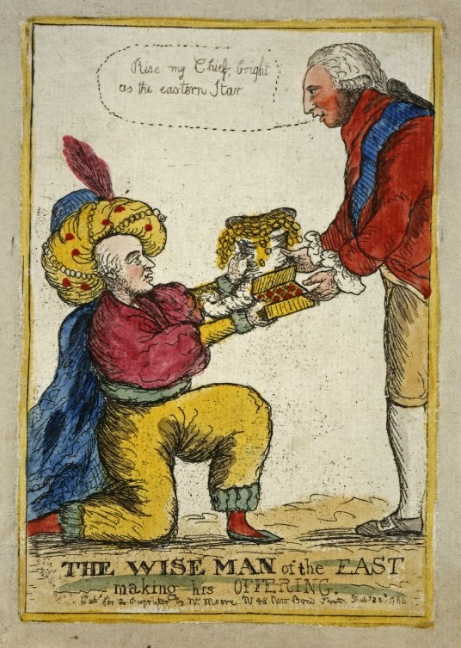
Until the early 19th century, neither the Dutch nor the British had much desire to push for changes in the social or cultural life of their Asian subjects. Beginning in the 1770s, however, rampant corruption on the part of company officials forced the British parliament to enact significant reforms in the administration of the East India Company and its colonies. By that time, most of those who served in India saw their brief tenure as a chance to strike it rich quickly They made great fortunes by cheating the company and exploiting the Indian peasants and artisans. The bad manners and conspicuous consumption of these upstarts, whom their contemporaries scornfully called nabobs, were satirized by leading English novelists of the age.
Eventually, their misconduct could not be ignored. A succession of political reforms culminated in sweeping measures.
Station #4: Why did Europe introduce western schools in their Asian colonies? Why didn’t they introduce western schools in Africa?
(see excerpt: page 558 in textbook)

Station #6: How were Africans in the Congo impacted when King Leopold of Belgium acquired this colony?
One of Belgium’s kings was also one of history’s greatest mass murderers. Leopold II (1835-1909) wanted his country to join the league of European empires, but the Belgian state refused to finance its part in western Europe’s expensive scramble for Africa. So they outsourced the task to Leopold, who used personal diplomacy to convince the European powers to grant him control of a large portion of the Congo basin. He promised to bring civilisation to the so-called dark continent.
The Congo colony was an astonishing 76 times the size of Belgium. When worldwide demand for rubber boomed, Leopold cashed in. Congolese workers were sent out into the jungle to slash down vines and layer their bodies with rubber latex. Later they would scrape it off their skin – often taking flesh and hair with it. The work was labour-intensive and injurious to health; the only economical way to collect it was via the forced mobilisation of Congolese society.
Leopold’s hell operated by an insane logic. Villages were set quotas of rubber and the gendarmerie were sent in to collect it – a process that was sped up by looting, arson and rape. If a village failed to reach its quota hostages would be taken and shot. To ensure that the gendarmerie didn’t waste their bullets hunting for food, they were required to produce the severed hands of victims. As a consequence a trade in severed hands developed among the villagers and those police that couldn’t reach their quotas. Europeans, rather than Africans, gained economically from rubber cultivation.
