- Cartography 4.1.2 (p. 2): What classical Chinese advances in cartography and navigation would influence Europeans in the early modern era?
Cartography or mapmaking (in Greek chartis = map and graphein = write) is the study and practice of making representations of the Earth on a flat surface.
In the year 267, Pei Xiu was appointed as the Minister of Works by Emperor Wu. Pei is best known for his work in cartography. Although map making and use of the grid existed in China before him, he was the first to mention a plotted geometrical grid and scale displayed on the surface of maps to gain greater accuracy in the estimated distance between different locations. Pei outlined six principles that should be observed when creating maps, two of which included the rectangular grid and scale for measuring distance.
Chinese cartography entered its golden age with the invention of the compass in the 11th century (Song Dynasty) and peaked with 15th century (Ming Dynasty) Chinese exploration of the Pacific under admiral Zheng He.

- Astrolabe 4.1.2 (p. 2): NAVIGATION - What does an astrolabe allow someone to do? What two civilizations influenced its design? How did the astrolabe influence European exploration?

What it is
- An astronomical instrument that calculated the position of the sun or stars
- Invented by the Greeks, borrowed by Islamic scholars
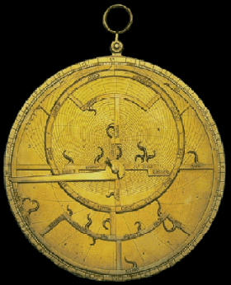
- Designed for use on boats in rough water and/or in heavy winds

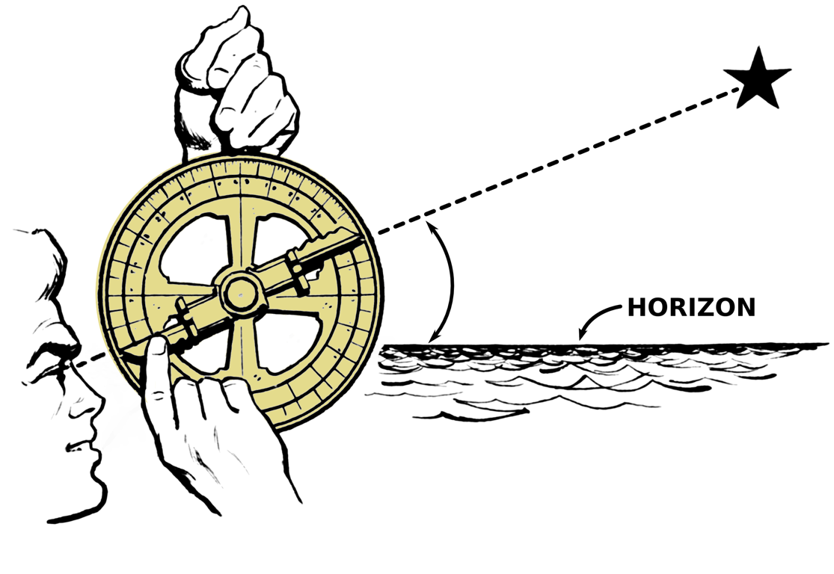
Impact on Exploration
- Adapted by the Portuguese at the beginning of the Early Modern Era for sea navigation
- People were more ambitious: able to go beyond the coast line to explore and trade with other continents

C: Caravel 4.1.2 (p. 2): What are caravels, and what was innovative about their design? What European country first developed this technology? What earlier technology probably influenced the design of the sails?
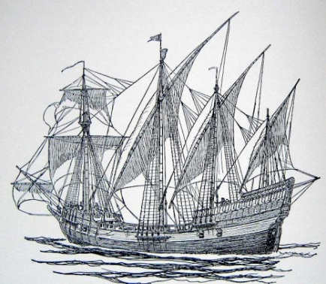
Portuguese mariners at the school of navigation supported by Henry the Navigator developed a new type of round-hulled ship with lateen rigging, the caravel. These craft were capable of sailing generous cargoes closer to the wind than any other European vessel. Without them, Portuguese expeditions along the African coast, and the later voyages to the Indies, would not have been possible.
Lateen sails (versus square sails) increased vessels’ speed and maneuverability and allowed them to sail windward (into the wind). The idea for lateen sails may have come from dhow ships used by Muslim merchants. Two of Christopher Columbus’ boats on his initial voyage to the “New World” were caravels – the Niña and the Pinta.

D. Columbus 4.1.3.B (p. 2): How did Christopher Columbus’ initial voyage to the Americas impact Spain? What other European powers became “big players” in this realm?
Although at first, Queen Isabella and King Ferdinand of Spain were resistant to funding Christopher Columbus’ voyage, ultimately, their finance minister convinced them it was a low-cost proposition and that it carried the possibility of enormous gain.

The Spanish monarchy did not think Columbus would come back alive from his expedition, but they certainly didn't want to lose out on the benefits if he did. Perhaps their lack of faith in the voyage was why they granted him 10% of the profits, noble status and hereditary governorship of the new territories to him and his descendants if he succeeded.
The immediate impact of Columbus’ trip across the Atlantic was to give Spain control of a vast new territory with seemingly limitless resources. This sparked a new age of exploration among other European powers, including Portugal, Britain, France and Holland, leading to an explosion of European colonization.
- Silver 4.1.4.B (p. 3): Describe the connection between silver resources in the Americas and the creation of a “global economy.” Describe working conditions for slaves working in the silver mines.
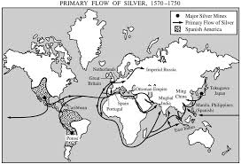
“The ore at Potosi silver mine is very rich black flint. So huge is the wealth that has been taken out of this range since the year 1545, when it was discovered, up to the present year of 1628, merely from the registered mines, according to most of the accounts in the Spanish royal records, 326,000,000 silver coins have been taken out.
The excavation so extensive that more than 3,000 Indian slaves worked away hard with picks and hammers, breaking up that flint ore; and when they have filled their sacks, loaded down with ore, climb up those ladders or rigging, some like masts and others like cables, and so trying and distressing that even an empty-handed man can hardly get up them.”

