Document A: from The Ethics of Confucius

Introduction
Confucius taught that harmony resulted when people accepted their place in society. He emphasized five key relationships, all of which were unequal, except for friendships. The other relationships were based on respect for authority: a subject to his ruler, a child to his parents, a wife to her husband, and younger brothers to elder brothers. By accepting these roles, Confucius said that people were fulfilling their duties and responsibilities and would live in harmony. His ideas influenced Chinese life and culture for many centuries.

Primary Source
‘Can there be love which does not lead to strictness with its objects?’ (Analects, bk. xiv., c. viii.)
For the purposes of discipline within the family, as well as for material support and protection, the woman was counselled to subject herself to the man. In the ‘Li Ki’ it was ordered thus: ‘The woman follows the man. In her youth she follows her father and elder brother; when married, she follows her husband; when her husband is dead, she follows her son.’ (Bk. ix., 10.)
The delights of a well-ordered household, where love and harmony hold sway, are pictured by the sage as follows: ‘It is said in the Book of Poetry: 'A happy union with wife and children is like the music of lutes and harps! When there is concord [agreement] among brethren, the harmony is delightful and enduring. Thus may you regulate your family and enjoy the delights of wife and children!' The Master said, 'In such a condition parents find perfect contentment.'‘ (Doctrine of the Mean, C. xv., v. 2, 3.)

— The Ethics of Confucius, by Miles Menander Dawson, [1915], at sacred-texts.com

Document B: from ‘The Analects’

Introduction
Confucius was a philosopher, with whom students and others talked and reasoned, in order to understand his culture-shaping views. He believed that morality was the cornerstone of an orderly society.

Primary Source
Tsze-chang asked Confucius, saying, ‘In what way should a person in authority act in order that he may conduct government properly?’ The Master replied, ‘Let him honour the five excellent, and banish away the four bad, things; –then may he conduct government properly.’ Tsze-chang said, ‘What are meant by the five excellent things?’ The Master said, ‘When the person in authority is beneficent[(n.) good] without great expenditure; when he lays tasks on the people without their repining [(v.) complaining]; when he pursues what he desires without being covetous [(adj.) desirous in a jealous way]; when he maintains a dignified [(adj.) showing rank or position] ease without being proud; when he is majestic without being fierce.’ 2. Tsza-Chang[PI1] said, ‘What is meant by being beneficent without great expenditure?’ The Master replied, ‘When the person in authority makes more beneficial to the people the things from which they naturally derive benefit; – is not this being beneficent without great expenditure? When he chooses the labours which are proper, and makes them labour on them, who will repine? When his desires are set on benevolent government, and he secures it, who will accuse him of covetousness? [(n.) a zealous desire for another’s property] Whether he has to do with many people or few, or with things great or small, he does not dare to indicate any disrespect; – is not this to maintain a dignified ease without any pride? He adjusts his clothes and cap, and throws a dignity into his looks, so that, thus dignified, he is looked at with awe; – is not this to be majestic without being fierce?’

— excerpt from The Chinese Classics (Confucian Analects) by James Legge

DOCUMENT C: Photograph of a Buddha statue in a Shanghai, China, temple

Introduction
Buddhism was introduced into China by missionaries and merchants from India. In contrast to Confucianism, Buddha promised escape from suffering through prayer and good works, and emphasized eternal happiness in an afterlife. Buddhism encouraged people to become monks and nuns, choosing spiritual meditation in monasteries over family life. Because of their strong family devotion, the Chinese were initially reluctant to accept this new religion. As Buddhism spread, monasteries became cultural centers, promoting education and the arts. Before long, some Confucian values were incorporated into Buddhism.

Primary Source
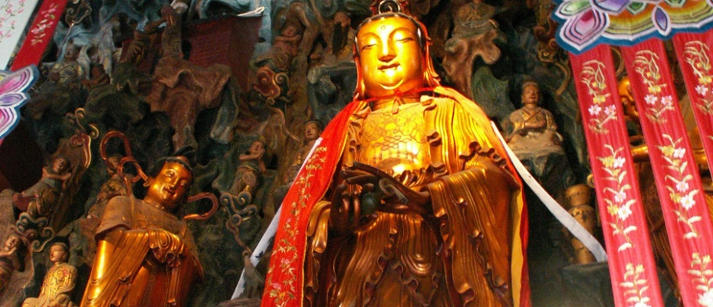

Document D: from ‘China’s Leaders Rediscover Confucianism’

Introduction
Confucianism developed during the late Zhou period in China. Confucius was considered a brilliant scholar who believed that educated people should serve in government to enact their good ideas. His teachings were philosophical, relating to social order and governing. Modern China, with its fading Marxist ideology, is once again returning to some Confucian values for governing.

Secondary Source
‘Confucius said, 'Harmony is something to be cherished,'‘ President Hu Jintao noted in February 2005. A few months later, he instructed China's party cadres to build a ‘harmonious society.’ Echoing Confucian themes, Hu said China should promote such values as honesty and unity, as well as forge a closer relationship between the people and the government.

The teaching curriculum for secondary schools now includes teaching of the Confucian classics, and several experimental schools have been set up that focus largely on the classics. Abroad, the government has been promoting Confucianism via branches of the Confucius Institute, a Chinese language and culture center similar to France's Alliance Française and Germany's Goethe Institute.

For the government, the promotion of Confucian values has several advantages. Domestically, the affirmation of harmony is meant to reflect the ruling party's concern for all classes. Threatened by rural discontent – according to official figures, there were 87,000 illegal disturbances last year – the government realizes that it needs to do more for those bearing the brunt of China's development. Internationally, the call for peace and harmony is meant to disarm fears about China's rapid rise.

— Daniel A. Bell, ‘China’s Leaders Rediscover Confucianism,’ The New York Times 2006

Document E: from ‘Caste in 21st Century India: Competing Narratives’

Introduction
Hindu beliefs included a system of social groups called castes. The caste system dictated status and occupation. Despite social inequalities, the castes provided a stable social order with each caste having its unique identity, occupations, and leaders. Many changes have taken place since ancient times. A recent study analyzes whether the caste system is still prevalent in 21st-century India.

Secondary Source
This paper has examined caste disparities [(n.) unique differences] in a variety of outcomes using data from a recent survey, the IHDS of 2004–05. The results paint an intriguing picture of caste stratification [(n.) arrangement of different parts] in modern India. On the one hand, there are promising signs of change as observed in high civic and political participation on the part of dalits [(n.) low caste Hindu group] and adivasis [(n.) ‘original inhabitants’ of the Indian subcontinent] and lower levels of disparities in metro cities; on the other hand, it is impossible to claim that caste has ceased to define either the opportunity structure or outcomes for a vast proportion of Indian population.

Results presented above suggest that caste background continues to define opportunities available to individuals. Landownership patterns remain unequal; lower castes have low educational status; have lower consumption expenditure resulting in lower access to nutrition, healthcare and private education; and have fewer social connections to important social institutions such as government services, healthcare and medical services. This unequal opportunity and access may well be the root cause of observed inequalities in health outcomes as well as other aspects of well-being (IIPS and Macro International 2007; Desai et al 2010; Shariff 1999). However, if these material disadvantages are combined with an absence of social discrimination, then it would be easy to argue that caste has been transformed into class [(n.) a rank in society based on common characteristics] in modern India and public policies do not need to focus on caste – policies directed at lower class individuals, regardless of their caste affiliation [(n.) connection], should be sufficient.

Have caste inequalities in modern India been transformed into class inequalities? If that were the case, then most of the caste disparities should disappear once controls for education and access to other productive resources are added. Our analysis shows no signs of that.

— Sonalde Desai and Amaresh Dubey, ‘Caste in 21st Century India: Competing Narratives’ 2012

Document E: from ‘Caste in 21st Century India: Competing Narratives’

Introduction
Hindu beliefs included a system of social groups called castes. The caste system dictated status and occupation. Despite social inequalities, the castes provided a stable social order with each caste having its unique identity, occupations, and leaders. Many changes have taken place since ancient times. A recent study analyzes whether the caste system is still prevalent in 21st-century India.

Secondary Source
This paper has examined caste disparities [(n.) unique differences] in a variety of outcomes using data from a recent survey, the IHDS of 2004–05. The results paint an intriguing picture of caste stratification [(n.) arrangement of different parts] in modern India. On the one hand, there are promising signs of change as observed in high civic and political participation on the part of dalits [(n.) low caste Hindu group] and adivasis [(n.) ‘original inhabitants’ of the Indian subcontinent] and lower levels of disparities in metro cities; on the other hand, it is impossible to claim that caste has ceased to define either the opportunity structure or outcomes for a vast proportion of Indian population.

Results presented above suggest that caste background continues to define opportunities available to individuals. Landownership patterns remain unequal; lower castes have low educational status; have lower consumption expenditure resulting in lower access to nutrition, healthcare and private education; and have fewer social connections to important social institutions such as government services, healthcare and medical services. This unequal opportunity and access may well be the root cause of observed inequalities in health outcomes as well as other aspects of well-being (IIPS and Macro International 2007; Desai et al 2010; Shariff 1999). However, if these material disadvantages are combined with an absence of social discrimination, then it would be easy to argue that caste has been transformed into class [(n.) a rank in society based on common characteristics] in modern India and public policies do not need to focus on caste – policies directed at lower class individuals, regardless of their caste affiliation [(n.) connection], should be sufficient.

Have caste inequalities in modern India been transformed into class inequalities? If that were the case, then most of the caste disparities should disappear once controls for education and access to other productive resources are added. Our analysis shows no signs of that.

— Sonalde Desai and Amaresh Dubey, ‘Caste in 21st Century India: Competing Narratives’ 2012

