History of the Belgian Congo: Imperialism, Genocide & Atrocities

The Belgian Congo is often cited as one of the most brutal and exploitative colonial regimes in modern history. It stands as an extreme example of the cruelty of European rule in Africa for the sake of economic gain.

King Leopold II and the Congo Free State
In the last decades of the nineteenth century the largely uncharted African continent was overrun by a sudden wave of European imperialist expansion. Driven by nationalist pride, imperial ambitions, and the hope of acquiring vast new economic resources, the leading nations of Europe each sought to claim a piece of the African 'cake' for themselves. The Berlin Conference of 1884 - 1885 formalized many of the major powers' claims in Africa and granted the coveted Congo River basin to King Leopold II of Belgium.
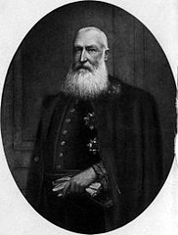
King Leopold II
Initially called the Congo Free State, the colony remained a personal possession of King Leopold II from 1885 until 1908 when it was taken over by the Belgian government and renamed the Belgian Congo.
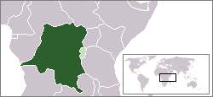
Map of the Belgian Congo
But why all the bother over Africa? Most African colonies at the time, including the Congo Free State, were created primarily for the economic exploitation of natural resources and labor. The major exports from the Congo region included ivory, rubber, and precious minerals, all of which were highly profitable and in great demand in Europe. To maximize the profitability, the interior regions of the Congo that could not be reached by river and steamship were steadily opened up through the construction of railroads.

Slavery, Genocide, and Economic Exploitation
The Congo Free State as it existed under Leopold II is largely known to history for its brutal exploitation of the native Congolese population and the mass death that resulted. Under Leopold II there were virtually no laws or restrictions protecting the native Congolese and their lands. The peoples of the Congo River basin were forced to work as porters, miners, rubber-tappers, woodcutters, and railway builders for European interests. Because there was little oversight and no form of organized government control Europeans were free to adopt brutal policies of kidnapping, mutilation, robbery, and murder to extract desired labor and resources from the local population.
The harvesting of rubber was a particularly arduous task. Rubber was in great demand in Europe for use in the manufacture of bicycle and automobile tires. But how could Europeans with limited resources and manpower force large numbers of local peoples to harvest rubber deep in the jungles of Africa? A colonial army called the force publique (public force) was created largely from local Africans and a handful of Belgian officers in order to marshal labor, quell revolts, and enforce the collection of rubber and ivory.
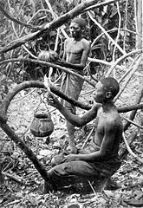
Congolese tap rubber vines
A common tactic used in the Congo Free State was to demand a certain quota of rubber from each village. Missing a quota was punished violently. It was not uncommon for the hands and feet of men, women, and children to be amputated as punishment for not collecting enough rubber or ivory. Hostages were taken from villages and used as leverage when demanding quotas. Villagers knew that not gathering the specified quota of goods could mean the execution of their their family.
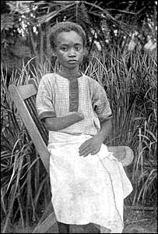
A Congolese girl with amputated hand

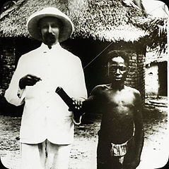
Amputation as punishment
Such inhumane policies drove many villages of the Congo to revolt and resist colonial rule. Rebellions were put down swiftly and violently, often by killing all those who refused to work. The bodies of rebels were often displayed as a warning to others.
While the death toll in the Congo Free State can never be truly known due to a lack of accurate records, historians have offered estimates as high as 10 million dead between 1885 and 1908. Colonial mismanagement and oppression led not only to the killing and maiming of native peoples, but also to overwork, disease, starvation, and a host of other factors that all combined in a massive loss of life.

