AP World History
Document-Based Question

Directions: The following question is based on the accompanying Documents 1-7. The documents have been edited for the purpose of this exercise. Historical Thinking Skill: Causation.

In your response you should do the following.
- Thesis: Present a thesis that makes a historically defensible claim and responds to all parts of the question. The thesis must consist of one or more sentences located in one place, either in the introduction or the conclusion.
- Argument Development: Develop and support a cohesive argument that recognizes and accounts for historical complexity by explicitly illustrating relationships among historical evidence such as contradiction, corroboration, and/or qualification.
- Use of the Documents: Utilize the content of at least six of the documents to support the stated thesis or a relevant argument.
- Sourcing the Documents: Explain the significance of the author’s point of view, author’s purpose, historical context, and/or audience for at least four documents.
- Contextualization: Situate the argument by explaining the broader historical events, developments, or processes immediately relevant to the question.
- Outside Evidence: Provide an example or additional piece of specific evidence beyond those found in the documents to support or qualify the argument.
- Synthesis: Extend the argument by explaining the connection between the argument and ONE of the following.
- A development in a different historical period, situation, era, or geographical area
- A course theme and/or approach to history that is not the focus of the essay (such as political, economic, social, cultural, or intellectual).
- A different discipline or field or inquiry (such as economics, government and politics, art history, or anthropology).

Prompt: Using the documents provided and your knowledge of world history, analyze the causes of increased interregional trade and exchange between 600 CE and 1450 CE throughout Afro-Eurasia.

Document 1
Source: Muslim Qur’an, around 620-650 CE.

O ye believers! devour not each other’s property among yourselves unlawfully save that be trading by mutual consent.

Woe to the cheaters! who, when they take measure of their dues from men, take it fully; and when they measure out to others or weigh out for them, they give less than is due.

And give full measure when you measure out and weigh with true balance. This is fair and better in the end.

If the two parties speak the truth and make it manifest, their transaction shall be blessed, and if they conceal and tell a lie, the blessing of their transaction shall be obliterated.

On the day of judgment, the honest, truthful Muslim merchant will take rank with the martyrs of the faith.

Document 2
Source: Tseng Kung-Liang, Compendium of Important Military Techniques, 1044 CE

When troops encountered gloomy weather or dark nights, and the directions of space could not be distinguished, they made use of the south-pointing fish [a fish-shaped iron leaf] to identify the directions. To use it, a small bowl filled with water is set up in a windless place, and the fish is laid as flat as possible on the water surface so that it floats, whereupon its head will point south.

Document 3
Source: Yaqut al-Hamawi, The Dictionary of Countries, early 1200s CE.

I begin with Iraq only because it is the center of this world, the navel of the earth, and I mention Baghdad first because it is the center of Iraq, the greatest city, which has no peer in the east or the west of the world in extent, size, prosperity, abundance of water, or health of climate, and because it is inhabited by all kinds of people, town-dwellers and country-dwellers. To it they come from all countries, far and near, and people from every side have preferred Baghdad to their own homeland. Goods are brought from India, Sind, China, Tibet, the Lands of the Turks, the Daylam [northern Iran], the Khazars [Central Asia], the Ethiopians, and others to such an extent that the products of the countries are more plentiful in Baghdad than in the countries from which they come. The palace of the Caliph stands in the midst of a vast park several hours in circumference.

Document 4
Source: Ibn Battuta, description of his travels to the city of Mogadishu on Africa’s eastern Swahili
Coast, 1331.

I took ship at Aden and…came to Mogadishu, which is an enormous town. Its inhabitants are merchants and have many camels, of which they slaughter hundreds every day for food. When a vessel reaches the port, it is met by small boats, in each of which are a number of young men, each carrying a covered dish containing food. He presents this to one of the merchants on the ship saying "This is my guest," and all the others do the same. Each merchant on disembarking goes only to the house of the young man who is his host, except those who have made frequent journeys to the town and know its people well; these live where they please. The host then sells his goods for him and buys for him, and if anyone buys anything from him at too low a price, or sells to him in the absence of his host, the sale is regarded by them as invalid. This practice is of great advantage to them.

Document 5
Source: Francesco Balducci Pegolotti on the journey from Italy to China,
Merchant’s Handbook, c.1340s CE

On the road you will find plenty of [Mongols]. You should furnish yourself with a dragoman [translator]. And besides the dragoman it will be well to take at least two good men servants, who are acquainted with the [Mongol] tongue. The road you travel to [China] is perfectly safe, whether by day or by night, according to what the merchants say who have used it. [China] is a province which contained a multitude of cities and towns. Among others there is one in particular, that is to say the capital city, to which is great resort of merchants, and in which there is a vast amount of trade.

Document 6

Source: Imperial inscription carved during the reign of Ming Emperor Yongle, Fujian Province in
Southeastern China, 1431.

The Imperial Ming Dynasty unifying seas and continents…even goes beyond the Han and Tang dynasties. The countries beyond the horizon and from the ends of the earth have all become subjects and to the most western of the western or the most northern of the northern countries, however far they may be, the distance and the routes may be calculated. Thus the barbarians from beyond the seas, though their countries are truly distant…have come to audience bearing precious objects and presents.

Document 7

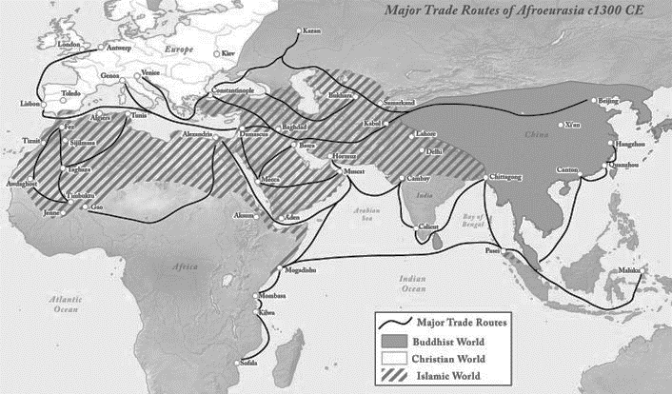

END OF DOCUMENTS

