Humanities: Postclassical Era Name_______________________________
Africa: Timbuktu, Swahili city-states

Answer the following questions using the World History Atlas, video clip and article provided, as well as the internet. Full sentences are not necessary.

Video clip
- Who was Mansa Musa?

- How did his hajj economically impact other communities?

- In what ways was his kingdom of Mali affected?

Map
- Identify and label the following: Timbuktu, Niger River, salt and gold resources, Sahara Desert, Swahili city-states. Add land and sea trade routes used in the postclassical era.

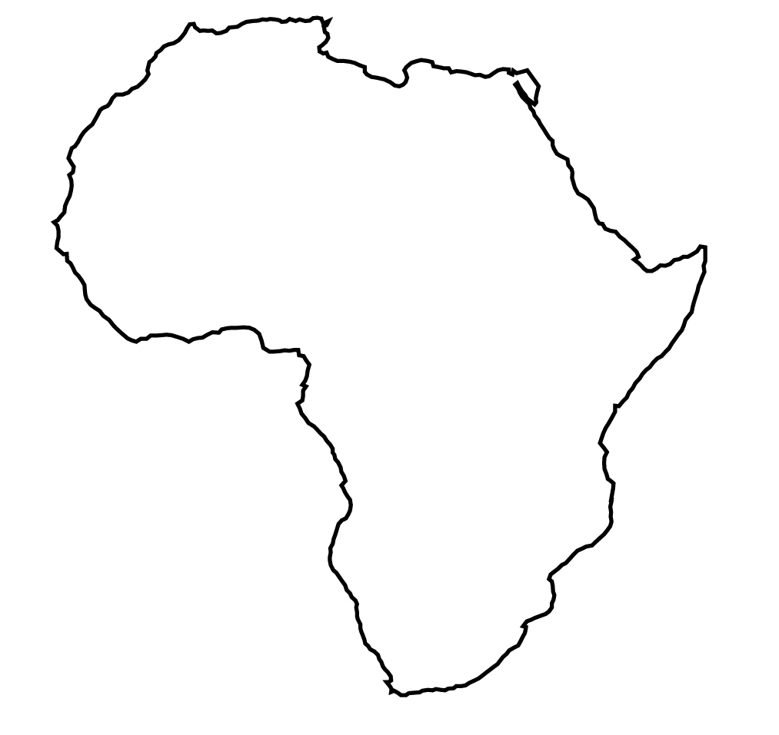
Article excerpts
- How and in what ways did Timbuktu come to be the “intellectual heart of Africa?”

- What events resulted in Timbuktu becoming known synonymously as “the ends of the earth?”

Internet
- What does “Sahara” mean in Arabic?

- List three characteristics of Dromedary/Arabic camels that made them well-suited for trade along the Sahara Desert.

- Describe two features of dhows that help us understand their role in advancing trade along Swahili city-states in the postclassical era.

