AP World History Unit 1 Key Concepts: Ancient Era
Technological and Environmental Transformations
Before 8,000 B.C.E. to circa 600 B.C.E.

Focus Question: Why were the Neolithic Revolutions “revolutionary?”

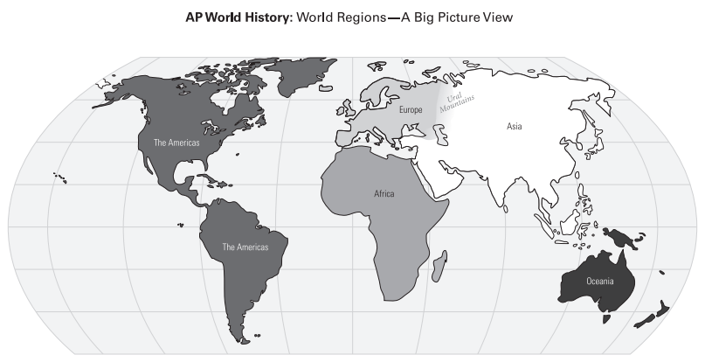

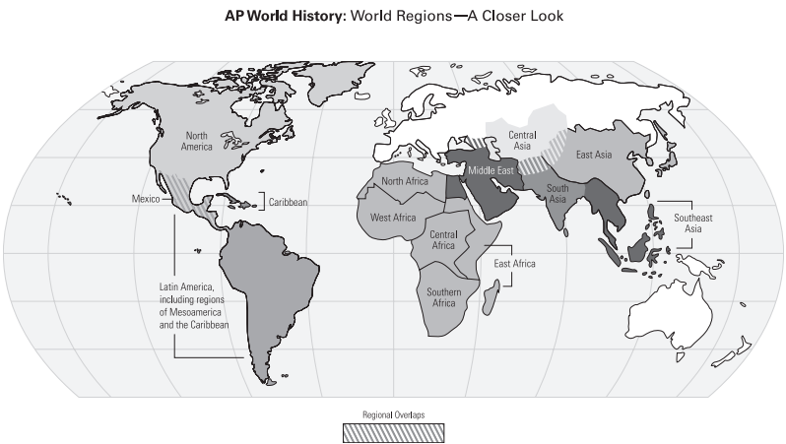

Snapshot (what was generally taking place at beginning of period)
- Nomadic hunting-foraging bands slowly migrating several miles per year from East Africa to habitable locations
- Animistic spiritual beliefs among nomadic cultures
- Relatively egalitarian nomadic hunting-foraging bands

Overview

Key Concept 1.1

The term Big Geography draws attention to the global nature of world history. Throughout the Paleolithic period, humans migrated from Africa to Eurasia, Australia, and the Americas. Early humans were mobile and creative in adapting to different geographical settings from savanna to desert to tundra. Humans also developed varied sophisticated technologies.

Key Concept 1.2

In response to warming climates at the end of the last Ice Age, about 10,000 years ago, some groups adapted to the environment in new ways, while others remained hunter-foragers. Settled agriculture appeared in several different parts of the world. The switch to agriculture created a more reliable, but not necessarily more diversified, food supply. Farmers also affected the environment through cultivation of selected plants to the exclusion of others, the construction of irrigation systems, and the use of domesticated animals for food and labor. Populations increased; village life developed, followed by urban life with all its complexity. Patriarchy and forced-labor systems developed, giving elite men concentrated power. Pastoralism emerged in parts of Africa and Eurasia. Like agriculturalists, pastoralists tended to be more socially stratified than hunter-foragers. Pastoralists’ mobility facilitated technology transfers through their interaction with settled populations.

Key Concept 1.3

About 5,000 years ago, urban societies developed, laying the foundations for the first civilizations. The term civilization is normally used to designate large societies with cities and powerful states. While there were many differences between civilizations, they also shared important features. They all produced agricultural surpluses that permitted significant specialization of labor. All civilizations contained cities and generated complex institutions, including political bureaucracies, armies and religious hierarchies. They also featured clearly stratified social hierarchies and organized long-distance trading relationships. Economic exchanges intensified within and between civilizations, as well as with nomadic pastoralists.

As populations grew, competition for surplus resources, especially food, led to greater social stratification, specialization of labor, increased trade, more complex systems of government and religion, and the development of record keeping. As civilizations expanded, people had to balance their need for more resources with environmental constraints. Finally, the accumulation of wealth in settled communities spurred warfare between communities and/or with pastoralists; this violence drove the development of new technologies of war and urban defense.
Outline

Key Concept 1.1 Big Geography and the Peopling of the Earth

Throughout the Paleolithic era, humans developed sophisticated technologies and adapted to different geographical environments as they migrated from Africa to Eurasia, Australasia, and the Americas.

- Archaeological evidence indicates that during the Paleolithic era, hunting-foraging bands of humans gradually migrated from their origin in East Africa to Eurasia, Australia and the Americas, adapting their technology and cultures to new climate regions.

  - Humans developed increasingly diverse and sophisticated tools – including multiple uses of fire – as they adapted to new environments.

  - People lived in small groups that structured social, economic and political activity. These bands exchanged people, ideas and goods.

Key Concept 1.2 The Neolithic Revolution and Early Agricultural Societies

Beginning about 10,000 years ago, some human communities adopted sedentism and agriculture, while others pursued hunter-forager or pastoralist lifestyles – different pathways that had significant social and demographic ramifications.

- The Neolithic Revolution led to the development of more complex economic and social systems.

  - Possibly as a response to climatic change, permanent agricultural villages emerged first in the lands of the eastern Mediterranean. Agriculture emerged independently in Mesopotamia, the Nile River Valley, Sub-Saharan Africa, the Indus River Valley, the Yellow River (or Huang He) Valley, Papua New Guinea, Mesoamerica and the Andes.

  - People in each region domesticated locally available plants and animals.

  - Pastoralism developed in Afro-Eurasian grasslands, affecting the environment in a variety of ways.

  - Agricultural communities had to work cooperatively to clear land and create the water control systems needed for crop production, drastically affecting environmental diversity.

- Agriculture and pastoralism began to transform human societies.

  - Pastoralism and agriculture led to more reliable and abundant food supplies, which increased the population and led to specialization of labor, including new classes of artisans and warriors, and the development of elites.

  - Technological innovations led to improvements in agricultural production, trade and transportation.
-example: pottery

-example: wheel

  - Patriarchal forms of social organization developed in both pastoralist and agrarian societies.

Key Concept 1.3 The Development and Interactions of Early Agricultural, Pastoral and Urban Societies

The appearance of the first urban societies 5,000 years ago laid the foundations for the development of complex civilizations; these civilizations shared several significant social, political, and economic characteristics.

- Core and foundational civilizations developed in a variety of geographical and environmental settings where agriculture flourished, including
- Mesopotamia in the Tigris and Euphrates River Valleys
- Egypt in the Nile River Valley
- Mohenjo-daro and Harappa in the Indus River Valley
- Shang in the Yellow River (or Huang He) Valley
- Olmec in Mesoamerica and
- Chavin in Andean South America.

- The first states emerged within core civilizations in Mesopotamia and the Nile River Valley.
  - States were powerful new systems of rule that mobilized surplus labor and resources over large areas. Rulers of early states often claimed divine connections to power. Rulers also relied on the support of the military, religious, or aristocratic elites.

  - As states grew and competed for land and resources, the more favorably situated had greater access to resources, produced more surplus food and experienced growing populations, enabling them to undertake territorial expansion and conquer surrounding states.

  - Pastoralists were often the developers and disseminators of new weapons and modes of transportation that transformed warfare in agrarian civilizations.
-example: iron weapons

-example: chariots
- Culture played a significant role in unifying states through laws, language, literature, religion, myths and monumental art.

  - Early civilizations developed monumental architecture and urban planning.
-examples: ziggurats, pyramids, defensive walls

  - Systems of record keeping arose independently in all early civilizations and writing and record keeping subsequently spread.
-examples: cuneiform, hieroglyphs

  - States developed legal codes that reflected existing hierarchies and facilitated the rule of governments over people.
-example: Code of Hammurabi (Babylonia)

  - New religious beliefs that developed in this period – including the Vedic religion, Hebrew monotheism, and Zoroastrianism – continued to have strong influences in later periods.

  - Interregional cultural and technological exchanges grew as a result of expanding trade networks and large-scale population movements, such as the Indo-European and Bantu migrations.
-examples: trade between Mesopotamia and Egypt; trade between Mesopotamia and the Indus Valley

  - Social hierarchies, including patriarchy, intensified as states expanded and cities multiplied.

