The Black Death in Primary Sources
Instructions: Based on the following collection of primary sources on the Black Death, as well as the textbook, board game simulation and video clips shown in class, write a thesis statement and a 2.5 page essay, using the PEA(R) model, on how this epidemic impacted the daily lives of medieval Europeans. Address at least three of the following: its psychological/social, cultural, economic and spiritual impact. You must use at least five of the sources from this packet in your essay, including at least two text passages. Submit your essay to Turnitin. See the last page of this packet for examples of how to cite different types of sources. Due:___________________
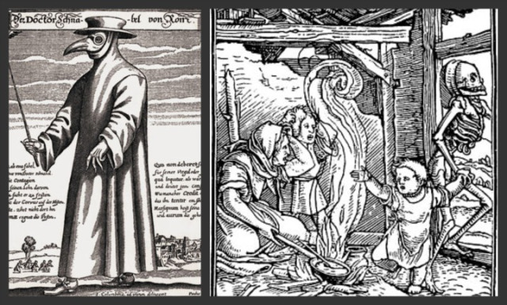
Protective clothing worn by plague physicians to prevent possible infection via “bad air” (his nose-case is filled with herbs and spices believed to keep off the plague)

Etchings by Paulus Furst of Nuremberg, Germany, 1656. Illustration from Bettmann/Corbis archive.
Gabriele de' Mussi, a notary from Piacenza, gave a vivid account of the plague in Kaffa and Sicily (Istoria de morbo sive mortalitate que fuit de 1348):
"Tell, O Sicily, and ye, the many islands of the sea, the judgements of God. Confess, O Genoa, what thou hast done, since we of Genoa and Venice are compelled to make God's chastisement manifest. Alas! our ships enter the port, but of a thousand sailors hardly ten are spared. We reach our homes; our kindred and our neighbours come from all parts to visit us. Woe to us for we cast at them the darts of death! Whilst we spoke to them, whilst they embraced us and kissed us, we scattered the poison from our lips. Going back to their homes, they in turn soon infected their whole families, who in three days succumbed, and were buried in one common grave. Priests and doctors visiting the sick returned from their duties ill, and soon were numbered with the dead. O death! cruel, bitter, impious death! which thus breaks the bonds of affection and divides father and mother, brother and sister, son and wife. Lamenting our misery, we feared to fly, yet we dared not remain."
(M.R., ed: D.S.) adapted from: George Deaux, The Black Death, 1347. New York: Weybright & Talley, 1969. Chapter IV, page 75.
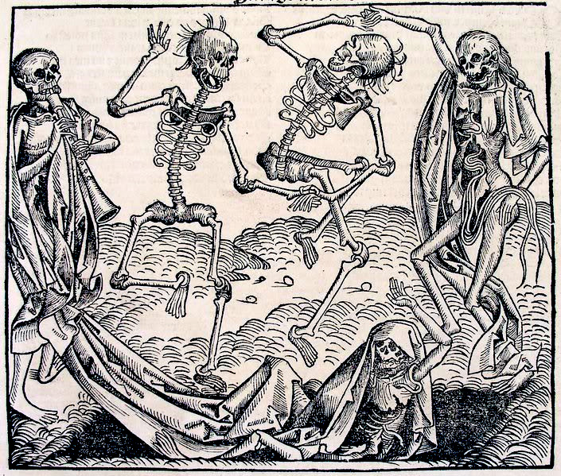
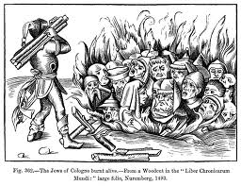Jews of Cologne burned alive, Book of Chronicles, Nuremberg, 1493.

Danse Macabre (Dance of Death) Chronicle of the World,
published by Hartman Schedel, 1493.

Petrarch: poet and scholar who endured the Black Death in Parma, Italy
My brother! My brother! My brother! A new beginning to a letter, though used by Marcus Tullius [Cicero] fourteen hundred years ago. Alas! my beloved brother, what shall I say? How shall I begin? Whither shall I turn? On all sides is sorrow; everywhere is fear. I would, my brother, that I had never been born, or, at least, had died before these times. How will posterity believe that there has been a time when without the lightnings of heaven or the fires of earth, without wars or other visible slaughter, not this or that part of the earth, but well-nigh the whole globe, has remained without inhabitants. When has any such thing been even heard or seen; in what annals has it ever been read that houses were left vacant, cities deserted, the country neglected, the fields too small for the dead and a fearful and universal solitude over the whole earth?... Oh happy people of the future, who have not known these miseries and perchance will class our testimony with the fables. We have, indeed, deserved these [punishments] and even greater; but our forefathers also have deserved them, and may our posterity not also merit the same...
(M.R., ed: D.S.) adapted from: George Deaux, The Black Death, 1347. New York: Weybright & Talley, 1969. Chapter IV, pages 92-94.
The Chronicle of Jean de Venette
This plague, it is said, began among the unbelievers, came to Italy, and then crossing the Alps reached Avignon, where it attacked several cardinals and took from them their whole household. Then it spread, unforeseen, to France, through Gascony and Spain, little by little, from town to town, from village to village, from house to house, and finally from person to person. It even crossed over to Germany, though it was not so bad there as with us. During the epidemic, God of His accustomed goodness deigned to grant this grace, that however suddenly men died, almost all awaited death joyfully. Nor was there anyone who died without confessing his sins and receiving the holy viaticum. . . .
Some said that this pestilence was caused by infection of the air and waters, since there was at this time no famine nor lack of food supplies, but on the contrary great abundance. As a result of this theory of infected water and air as the source of the plague the Jews were suddenly and violently charged with infecting wells and water and corrupting the air. The whole world rose up against them cruelly on this account. In Germany and other parts of the world where Jews lived, they were massacred and slaughtered by Christians, and many thousands were burned everywhere, indiscriminately.
Richard A. Newhall, ed., Jean Birdsall, translator, The Chronicles of Jean de Venette. New York: Columbia University Press, 1953, pages 48-51.
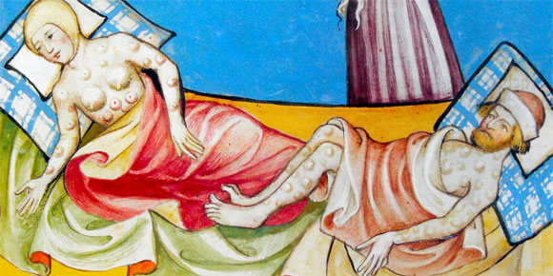
Illustration of the Black Death from the Toggenburg Bible (1411)

The Florentine Chronicle of Marchione di Coppo Stefani
In the year of the Lord 1348 there was a very great pestilence in the city and district of Florence. It was of such a fury and so tempestuous that in houses in which it took hold previously healthy servants who took care of the ill died of the same illness. Almost none of the ill survived past the fourth day. Neither physicians nor medicines were effective. Whether because these illnesses were previously unknown or because physicians had not previously studied them, there seemed to be no cure. There was such a fear that no one seemed to know what to do. When it took hold in a house it often happened that no one remained who had not died. And it was not just that men and women died, but even sentient animals died. Dogs, cats, chickens, oxen, donkeys sheep showed the same symptoms and died of the same disease. And almost none, or very few, who showed these symptoms, were cured. The symptoms were the following: a bubo in the groin, where the thigh meets the trunk; or a small swelling under the armpit; sudden fever; spitting blood and saliva (and no one who spit blood survived it). It was such a frightful thing that when it got into a house, as was said, no one remained. Frightened people abandoned the house and fled to another. Those in town fled to villages. Physicians could not be found because they had died like the others. And those who could be found wanted vast sums in hand before they entered the house. And when they did enter, they checked the pulse with face turned away. They inspected the urine from a distance and with something odoriferous under their nose.
Child abandoned the father, husband the wife, wife the husband, one brother the other, one sister the other. In all the city there was nothing to do but to carry the dead to a burial. And those who died had neither confessor nor other sacraments. And many died with no one looking after them. And many died of hunger because when someone took to bed sick, another in the house, terrified, said to him: "I'm going for the doctor." Calmly walking out the door, the other left and did not return again. Abandoned by people, without food, but accompanied by fever, they weakened. There were many who pleaded with their relatives not to abandon them when night fell. But [the relatives] said to the sick person, "So that during the night you did not have to awaken those who serve you and who work hard day and night, take some sweetmeats, wine or water. They are here on the bedstead by your head; here are some blankets." And when the sick person had fallen asleep, they left and did not return. Many died unseen. So they remained in their beds until they stank. And the neighbors, if there were any, having smelled the stench, placed them in a shroud and sent them for burial. The house remained open and yet there was no one daring enough to touch anything because it seemed that things remained poisoned and that whoever used them picked up the illness.
At every church, or at most of them, they dug deep trenches, down to the waterline, wide and deep, depending on how large the parish was. And those who were responsible for the dead carried them on their backs in the night in which they died and threw them into the ditch, or else they paid a high price to those who would do it for them. The next morning, if there were many [bodies] in the trench, they covered them over with dirt. And then more bodies were put on top of them, with a little more dirt over those; they put layer on layer just like one puts layers of cheese in a lasagna.
The beccamorti [literally vultures] who provided their service, were paid such a high price that many were enriched by it. Many died from [carrying away the dead] , some rich, some after earning just a little, but high prices continued. Servants, or those who took care of the ill, charged from one to three florins per day and the cost of things grew. The things that the sick ate, sweetmeats and sugar, seemed priceless. Capons and other poultry were very expensive and eggs cost between twelve and twenty-four pence each; and he was blessed who could find three per day even if he searched the entire city. Finding wax was miraculous. A pound of wax would have gone up more than a florin if there had not been a stop put [by the communal government] to the vain ostentation that the Florentines always make [over funerals]. Thus it was ordered that no more than two large candles could be carried[in any funeral]. Churches had no more than a single bier which usually was not sufficient. Spice dealers and beccamorti sold biers, burial palls, and cushions at very high prices. The rich dressed in modest woolens, those not rich sewed [clothes] in linen. Priests could not sound bells, sell benches, nor cry out announcements because the sick hated to hear of this and it discouraged the healthy as well. Priests and friars went [to serve] the rich in great multitudes and they were paid such high prices that they all got rich.
Many processions, including those with relics and the painted tablet of Santa Maria Inpruneta, went through the city crying out "Mercy" and praying and then they came to a stop in the piazza of the Priors. There they made peace concerning important controversies, injuries and deaths.
None of the guilds in Florence was working. All the shops were shut, taverns closed; only the apothecaries and the churches remained open. If you went outside, you found almost no one.

The Florentine Chronicle of Marchione di Coppo Stefani. Baldassarre Bonainti, 1385, published by ed. Niccolo Rodolico, 1903, Citta di Castello, S. Lapi.

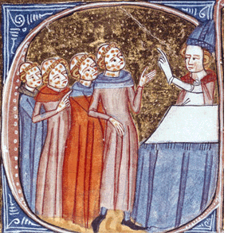
Pieter Bruegel, Triumph of Death, 1562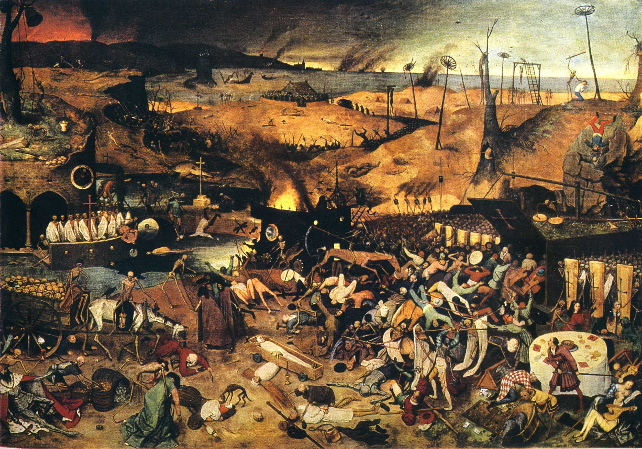
Monks with plague, late 14th century
illuminated manuscript from Omne Bonum,
by James le Palmer, London, 1375.

Primary Source citation examples

Brown, Nick, and Josh Brolin. Mankind: The Story of All of Us: Plague. United States: A&E Television Networks, 2012.
Ancient Mysteries: The Black Death. Perf. Leonard Nimroy. A&E Home Video, 2005. DVD.
Bloom, Alayna. “High and Late Middle Ages.” Evergreen High School, Evergreen. 10 Jan. 2018. Lecture.
Unknown. “Bubonic Plague Board Game Simulation.”
“The Jews of Cologne Burnt Alive,” from a Woodcut in the “Liber Chronicarum Mundi,” Nuremberg, 1493.
Illustration of bubonic plague. The Bible, (1411).
Ellis, Elisabeth Gaynor. World History. Boston, M.A.: Pearson Education, Inc., 2016.

