World History
Catherine II, the Great (1729-96): Empress of Russia
Focus question: How was Catherine the Great an “Enlightened despot?”

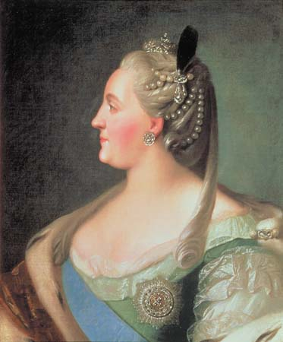
Catherine II ruled Russia from 1762-96, during a period of unprecedented growth of empire. Astute and autocratic, she expanded Russian dominions, overhauled administrative structures, and vigorously pursued Westernization policies. To foster economic development, she encouraged trade by ending various restrictions on commerce, and promoted the settlement of underpopulated areas by attracting both Russians and foreigners to them.
With ambitious plans for domestic reform, Catherine realized Russia needed prolonged peace and stability, if proper change were to be effected. As an "enlightened despot," motivated by the ideas of the Enlightenment, Catherine came to believe that a wise and benevolent ruler, acting according to the dictates of reason, could ensure the well-being of her subjects. In this spirit, Catherine undertook the first major reform, that of Russia's legal system, which was based on the inequitable, archaic and inefficient Code of Laws, dating back centuries. She oversaw the formulation of the "Instruction," which received wide acclaim throughout Europe. Among its features, it proposed a system granting equal protection under law to all persons, and emphasized prevention of criminal acts rather than the imposition of harsh punishment.
For security reasons, she reorganized provincial administration to favor the nobility. She endeavored to expand the country's educational facilities, and proceeded to increase the number of elementary and secondary schools. The arts and sciences received much attention, and St. Petersburg became one of Europe's major cultural centers during her reign. Support for music, theater and painting increased, and The Academy of Sciences became a world-class institution of scholarship.

