World History
Code of Hammurabi – Classroom Set

Overview: Leaders throughout history have had to grapple with the task of creating just, or fair, laws. Hammurabi, king of Babylon, wrote one of the world’s oldest sets of laws 4,000 years ago. This law code can by analyzed to understand the values of ancient Mesopotamia and to explore the idea of fairness.

Task 1: With a partner, read through the two cases below and discuss the questions that follow. In each case, you will consider justice in three ways: Is the outcome fair to the accused? Is the outcome fair to the victim? Is the outcome in the best interest of the general society?

--------------------------------------------------------------------------------------------------------------------
Case A: Eddie is caught shoplifting a cell phone at Best Buy. Eddie is 15 years old. It is a first offense. The police call his parents, and Eddie returns the phone. There will be no criminal record.

In judging whether this is a fair handling of the case, ask:
- Is it fair to Eddie?
- Is it fair to Best Buy?
- Is it fair to society? Is it in the best interest of society?
-------------------------------------------------------------------------------------------------------------------

Case B: J.D. is caught shoplifting a cell phone at Best Buy. J.D. is 19 years old. This will be his third felony conviction, all for shoplifting. Because of the Three Strikes law, his state requires that he serve a minimum of ten years in prison with no chance of parole.

In judging whether this is a fair handling of the case, ask:
- Is it fair to J.D.?
- Is it fair to Best Buy?
- Is it fair to society? Is it in the best interest of society?

-----------------------------------------------------------------------------------------------------------------

Task 2: Pick one rule at Evergreen High School Then decide if it is just. Explain.
- Is it fair to the rule breaker?
- Is it fair to those who are harmed?
- Is it fair to the greater school community?

Document A

The stele, carved from black diorite, stands more than eight feet tall and weighs four tons.

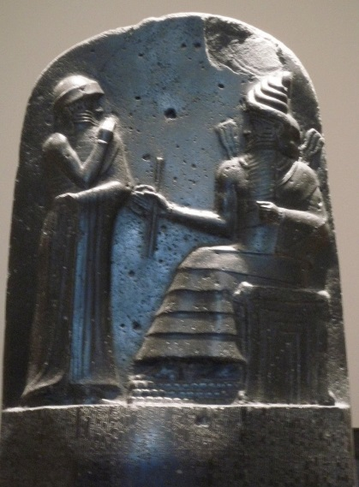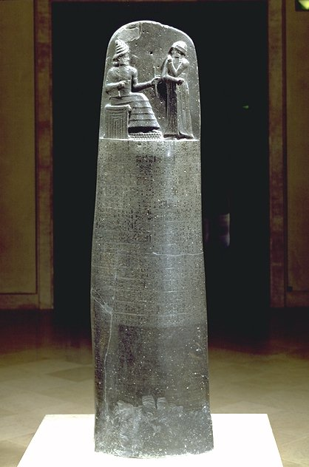
Near the base are the 282 laws, organized by theme, including family life, agriculture, theft and professional standards.
The carving at the top of the stele shows Hammurabi standing before Shamash, the god of justice, who is seated on his throne. Shamash is instructing Hammurabi in the law.

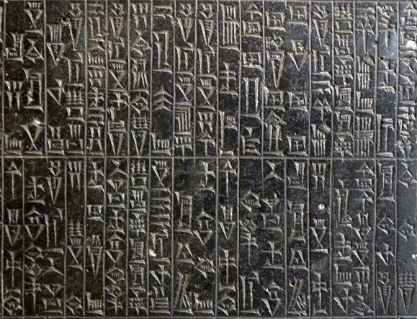
The Code is written in wedge-shaped cuneiform letters.

Document B

Excerpts from the Epilogue of Hammurabi’s Code, circa 1754 B.C.E.
…Hammurabi, the protecting king am I…That the strong might not injure the weak, in order to protect the widows and orphans,…I set up these my precious words, written upon my memorial stone, before the image of me, as king of righteousness.

…By the command of Shamash, the great god and judge of heaven and earth, let righteousness go forth in the land…Let no destruction befall my monument;…let my name be ever repeated; let the oppressed, who has a case at law, come and stand before this my image as king of righteousness; let him read the inscription, and understand my precious words…

Document C: Family Law
Law 129: If a married lady is caught [in adultery] with another man, they shall bind them and cast them into the water.

Law 148: If a man has married a wife and a disease has seized her, if he is determined to marry a second wife, he shall marry her. He shall not divorce the wife whom the disease has seized. She shall dwell in the house they have built together, and he shall maintain her as long as she lives.

Law 168: If a man has determined to disinherit his son and has declared before the judge, “I cut off my son,” the judge shall inquire into the son’s past, and, if the son has not committed a grave misdemeaner…, the father shall not disinherit his son.

Law 195: If a son has struck his father, his hands shall be cut off.

Document D: Property Law
Law 21: If a man has broken through the wall [to rob] a house, they shall put him to death and pierce him, or hang him in the hole in the wall which he has made.

Law 23: If a robber is not caught, the man who has been robbed shall formally declare whatever he has lost before a god, and the city and the mayor in whose territory or district the robbery has been committed shall replace for him whatever he has lost.

Law 48: If a man has borrowed money to plant his fields and a storm has flooded his field or carried away the crop,…in that year he does not have to pay his creditor.

Laws 53, 54: If a man has opened his trench for irrigation and the waters have flooded his neighbor’s field, the man must restore the crop he has caused to be lost.

Document E: Personal Injury Law
Law 196: If a man has knocked out the eye of a free man, his eye shall be knocked out.

Law 199: If he has knocked out the eye of a slave…he shall pay half his value.

Law 209: If a man strikes the daughter of a free man and causes her to lose the fruit of her womb, he shall pay 10 shekels of silver…

Law 213: If he has struck the slave-girl of a free man and causes her to lose the fruit of her womb, he shall pay 2 shekels of silver.

Law 215: If a surgeon has operated with a bronze lancet on the body of a free man…and saves the man’s life, he shall receive 10 shekels of silver.

Law 218: If a surgeon has operated with a bronze lancet on a free man for a serious injury, and has caused his death,…his hands shall be cut off.

World History Name(s)______________________________________________
Code of Hammurabi

Background Reading Questions: Full sentences are not necessary.
- Into what three social classes was the population divided?

- In your own words, describe what Hammurabi’s Code is.

- Define these terms:
  - city-state:

  - Babylonia:

  - Mesopotamia:

  - cuneiform:

  - stele:

Understanding the Question (refer to last paragraph of reading)
- What is the analytical question asked by this Mini-Q?

- What terms in the question need to be defined?

- Rewrite the question in your own words.

Pre-Bucketing: Create two starter buckets that identify the opposing positions on the question. Then, you will pick the position you feel contains the strongest evidence and create three “reason” buckets for that position.

THEN

Document Analysis: Full sentences are not necessary.

Documents A and B
- From where does Hammurabi get the laws?

- According to Hammurabi, what was his purpose for having written these laws?

- How could these documents be used as evidence that Hammurabi’s Code was just?

Document C
- In Law 129, what does it mean to “bind them and cast them into the water?”

- In Law 168, what does it mean to “disinherit” a son?

- Two crimes in the document result in physical punishment. What are those crimes? How might Hammurabi argue that the punishments were just?

- Hammurabi said that his code was meant to protect the weak. Is there evidence in this document that the code did so?

- Overall, do you think these laws regarding family are just? That is, are they fair to the accused? To the victim? To society as a whole?

Document D
- In Law 21, what is the penalty for breaking into a home? How might Hammurabi justify the harsh punishment?

- In Law 23, if the robber is not caught, who reimburses the victim for his or her loss? How might Hammurabi have justified reimbursing the victim?

- In Law 48, what is a creditor? Do you think this law is fair to creditors?

- Overall, do you think these laws regarding property are just?

Document E
- Examine laws 196 and 199. How do you think Hammurabi would justify the different punishments for the same crime?

- What is the meaning “fruit of her womb?”

- How might Hammurabi argue that laws 215 and 218 were just?

- How could you use these laws about personal injury to argue that Hammurabi’s Code was not just?

- Is justice absolute That is, is a just punishment in 1800 B.C.E. also a just punishment today? Explain your thinking.

Bucketing – Look over all the documents and organize them into your final buckets. Write labels under each bucket and place the letters of the documents in or under the buckets where they belong. You can put a document in more than one bucket. Remember, your buckets are going to become your body paragraphs.

Thesis Development and Road Map – On the chicken foot below, write your thesis and your road map. Your thesis is always an opinion and answers the Mini-Q question. The road map is created from your bucket labels and lists the topic areas you will examine in order to prove your thesis.

___________________________________________________ _________________________________________________

Mini-Q Essay Outline Guide: Group essay must be submitted to Turnitin (see Mrs. Bloom’s website for details).

Working Title

Paragraph #1
Grabber

Background

Stating the question with key terms defined

Thesis and road map

Paragraph #2
Baby Thesis for bucket one

Evidence: supporting detail from documents, with document citation

Argument: connecting evidence to the thesis

Paragraph #3
Baby Thesis for bucket two

Evidence

Argument

Paragraph #4
Baby Thesis for bucket three

Evidence

Argument

Paragraph #5
Conclusion: “Although” statement and restatement of main idea

