AP World History
SAQ: Short Answer Question

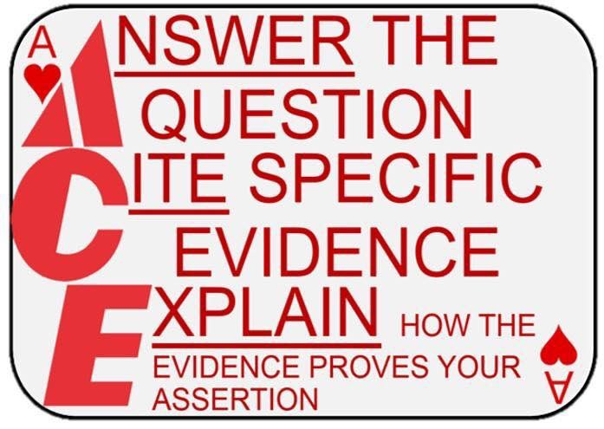

Formula
A - answer the question directly (this is the assertion or claim)

C - cite specific, factual evidence (“for example…”)
E - explain how the evidence proves the assertion (“this showed/reflected…” OR “as a result…”)

Tips
- you must directly reference/cite the stimulus in your answer

- develop your answer, but don’t add any “fluff” – your answer must fit inside the box (see example on back)

- write a separate sentence for each ACE element

