Humanities: “Total War”
Focus Questions: What weapons were created as a result of the Industrial Revolution, and how did the nature of warfare change as a result? Summarize what is meant by the concept “total war.”
World War I was characterized by the use of new weapons that were the byproducts of the Second Industrial Revolution (1850+). These new weapons provided unprecedented destructiveness and forced army generals to adapt their traditional tactics to overcome the new lethal weaponry and obstacles such as the barbed wire. Firepower replaced manpower as the instrument of victory. This represented a revolution in the conduct of war.
Shell-fire was merciless to troops in the open. The response was to get out of the open and into the ground. Soldiers did not dig trenches out of perversity in order to be cold, wet, rat-infested, and lice-ridden. They dug them in order to survive. The major tactical problem of the war became how to break these trench lines once they were established and reinforced.
Some examples
Machine Guns: The machine gun was the weapon that really made the difference in the Great War as it gave the infantry so high a rate of fire to the point that it rendered the horse and the cavalry useless in the battlefield. The machine gun was the initiator of the trench warfare.

The Germans used the Maschinengewehr 08, which fired 7.92mm ammunition from a 250-round fabric belt and it carried 2,150 meters effective range. The German Army deployed over 15,000 of these machine-guns on the Western Front during the first year of the war.
Invented in 1881 by the American Hiram Maxim, the Maxim Machine-Gun was the standard British machine gun during World War I. Using the energy of each bullet’s recoil force to eject the spent cartridge, it could fire 600 rounds per minute.
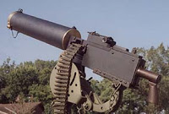
Flamethrowers: using liquid fuel, a flamethrower was a weapon designed to spew a long stream of fire. Hand-carried by infantry, or mounted on tanks, modern flamethrowers were first used during World War I to overcome the trench warfare conditions that made the war static. But to operate this weapon was extremely dangerous as the fuel in the small tank on the operator’s back was unstable.
Hand grenades: Considered useful for siege and assault operations, the hand grenade was intensively used in World War I. The hand grenade featured an explosive charge encased in metal can mounted on a wooded stick for throwing. Over 75,000,000 hand grenades were made during the Great War.
Tanks: The development of tanks in the Great War came about as a solution to the stalemate of trench warfare. They did have reliability problems, but when they were working they could cross trenches or craters of 9 feet and drive right through barbed wire. It was still common for them to get stuck, especially in larger bomb craters, but overall the rhomboid shape allowed for extreme terrain mobility. Their steel armor could stop small arms fire and fragments from high-explosive artillery shells.
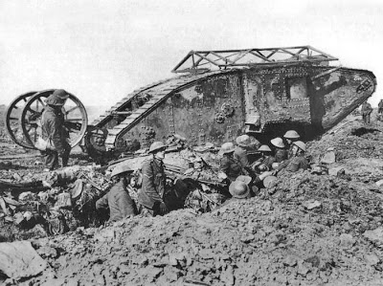British Mark I Tank
“Total War”
Almost the whole of Europe mobilized to wage World War I, since it demand so much: more men, more weapons, more ammunition, more money, more skills, more morale, and more food. Young men were removed from production jobs to serve in military roles, and were replaced on the production line by women. Rationing occurred on the home fronts. One of the features of Total War in Britain was the use of government propaganda posters to divert all attention to the war on the home front. Posters were used to influence public opinion about what to eat and what occupations to take, and to change the attitude of support towards the war effort. Even the Music Hall was used as propaganda, with propaganda songs aimed at recruitment.
The Allies were in a stronger position than Germany in that they had access not only to their home populations but also to those of their empires. Approximately 630,000 Canadians, 412,000 Australians, 136,000 South Africans, and 130,000 New Zealanders served in the British army during the war. Very large numbers of Indian troops and a small number of Africans also served. The French recruited some 600,000 combat troops from North and West Africa and a further 200,000 laborers. And of course there were the Americans. American troops arrived in France at the rate of 150,000 a month in 1918. Truly the new world had come in to redress the balance of the old.
The cost of all this in human terms was 8.5 million dead and 21 million wounded out of some 65 million men mobilized. The real impact was moral. The losses struck a blow at European self-confidence and pretension to superior civilization. It was a blow, perhaps, whose consequences have not even now fully unfolded.

