World History: Weapons of World War I
Focus Questions: How did the Industrial Revolution transform warfare? Why did trench warfare emerge? What weapons were created to try to overcome trench warfare conditions?
World War I was characterized by the use of new weapons that were the byproducts of the Second Industrial Revolution (1850+). These new weapons forced army generals to change their traditional tactics and use new ones to overcome the new lethal weaponry and obstacles such as the barbed wire.
Machine Guns: The machine gun was the weapon that really made the difference in the Great War as it gave the infantry so high a rate of fire to the point that it rendered the horse and the cavalry useless in the battlefield. The machine gun was the initiator of the trench warfare.

The Germans used the Maschinengewehr 08, which fired 7.92mm ammunition from a 250-round fabric belt and it carried 2,150 meters effective range. The German Army deployed over 15,000 of these machine-guns on the Western Front during the first year of the war.
Invented in 1881 by the American Hiram Maxim, the Maxim Machine-Gun was the standard British machine gun during World War I. Using the energy of each bullet’s recoil force to eject the spent cartridge, it could fire 600 rounds per minute. This .303-caliber machine gun was water-cooled.
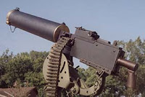
The Browning M1917 was the American standard machine gun during the war. Invented by the American gunsmith John Moses Browning, this .30-caliber (7.62mm) machine gun was water-cooled and used the bullet ignition gas for the recoil to eject the spent cartridge and reload. It could fire 600 rounds per minute, utilizing a 250-round belt. The Browning Machine Gun weighed 103 pounds (47kg) with tripod, water, and ammunition and had a barrel length of 24 inch.
Invented by the American-born Benjamin Hotchkiss, the French utilized the Hotchkiss 8mm M1914 machine gun throughout the war. This machine gun effective range was 3,600 meters and it could fire 600 rounds per minute using a 249-round belt.
Flamethrowers: using liquid fuel, a flamethrower was a weapon designed to spew a long stream of fire. It was used mainly against pillbox, machine gun nestles, and other strong enemy positions. Hand-carried by infantry, or mounted on tanks, modern flamethrowers were first used during World War I to overcome the trench warfare conditions that made the war static. But to operate this weapon was extremely dangerous as the fuel in the small tank on the operator’s back was unstable, and the British and the French poured rifle fire into the area of attack where flamethrowers were used and their operators were treated without mercy when they were taken prisoners.
Hand grenades: Considered useful for siege and assault operations, the hand grenade was intensively used in World War I by both belligerent armies. At the outbreak of the war, the Germans were ahead of the rest in terms of grenade development with more than 80,000 hand grenades ready for use. The German stick hand grenade featured an explosive charge encased in metal can mounted on a wooded stick for throwing. At the start of the war, the British troops improvised their own hand grenade, the Jam Tin grenade, which was later replaced with manufactured versions such as the Mills bomb; a fragmentation grenade available to front-line troops. The Mills bomb was developed at the Mills Munitions Factory in Birmingham. The United States developed the M67, which was a fragmentation grenade with a smooth exterior. 75,000,000 hand grenades were made during the Great War.
Bolt-Action Rifles: The rifle was the number one infantry weapon during the war. All of the rifles used during the armed conflict were breech-loading, bolt-action rifles, which were improved versions of earlier models developed during the second half of the 19th century.

Tanks: The development of tanks in the Great War came about as a solution to the deadlock of trench warfare. Originally called “landships” by the British Army, the first Mark I Tank prototype was tested in September, 1915, and it was first used at the Battle of the Somme, in September, 1916.
Artillery: Artillery guns had a big impact in the World War I, playing an important role during great battles. For example, the 420mm Howitzer Big Bertha stands out in World War I. It weighed 43 tons, had a length of 5.88 meters and an effective range of 12 kilometers. The Big Bertha fired an 820 kg shell.
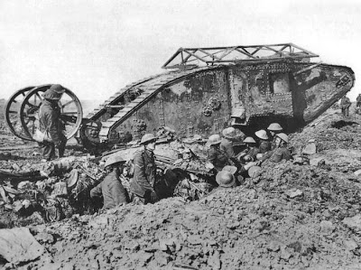British Mark I Tank
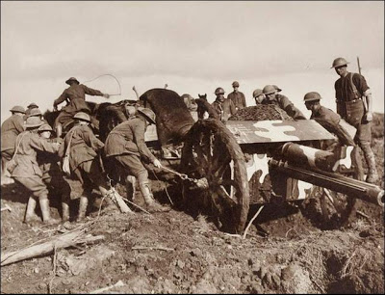British 18-Pounder Howitzer
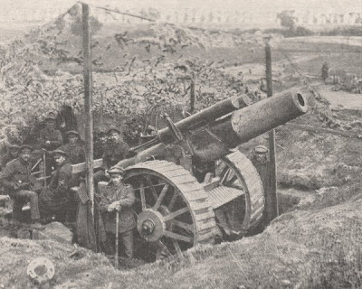British BL 8-inch Howitzer
